Wined and dined
Editorial/Ad..
The restaurant occupied the whole ground floor of the hotel, its reputation in the le Loire valley attracted diners from afar and tonight that included my client, his wife and me. Whilst the food and service was the best the French could offer I wish to share, from this introductory experience the topic of wine enjoyment.

The purpose of the evening was to discuss the design of a new six-figure kitchen for my client’s latest property (part shown below) - one aspect of which was a wine storage system. Yet, that night over the meal, we discussed anything but the project – only the satisfaction exquisite food and fine wine inspires.

By Glenn Designs

I sampled wines for each course that night; for the dessert my client ordered a bottle of his favourite vintage, one of the special reserves which the hotelier had laid up years ago in their vault. (Which, incidentally, she got wrong; the ensuing debate sparked the informed opinions of all the other fine diners in the room – a novel experience, but not very British).

To experience the difference between a good wine and a really good wine, occasionally requires assistance - but the learning curve really can be fun.

Later we were invited to local vineyards where, standing inside their caves, we sampled their reserves also. The occasional bottle or two is great to lay-up for those “future special occasions” and does look most impressive in a display.
.Something to be proud of -
Over the years I have designed and built cabinets for collectors of all kinds of passions. The gratification connoisseurs anticipate is made all the more appealing in a well presented show case. A good wine display is no different and whets the appetite of those with whom you wish to share.
Here at Glenn Designs we offer a unique service in wine cabinet presentation. Individually crafted to suit your existing or future décor we can tone all woods in style, stain or colour. Furthermore, our concept presents the bottles - label out, not just a view of their cap ends. Seeing a wine selection is better than just reading about one, to experience both in the company of friends is even better.

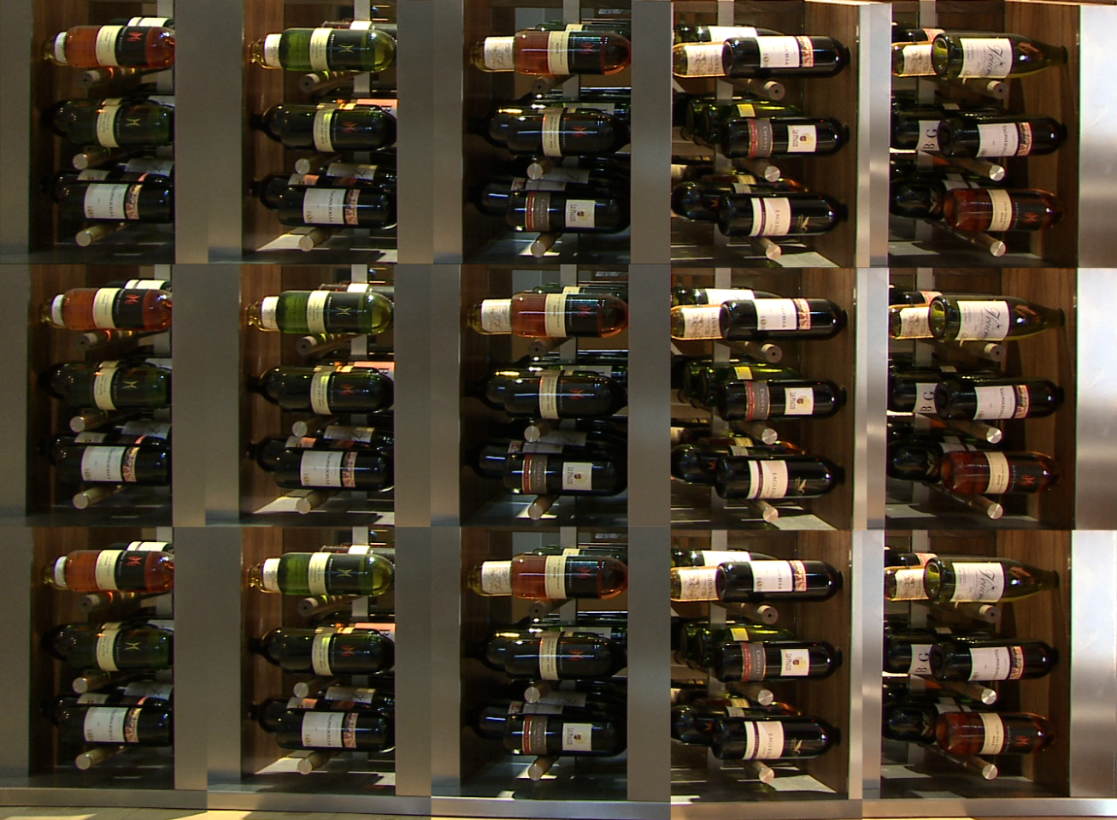
By Glenn Designs
So, what is the ideal wine storage environment? Surprisingly, it does not have to be cold or dry. The conditions in which most wine is stored should echo that of the caves in which they mature; which can vary locally between 11-14 degrees C. and a humidity of 55% upwards.
A quality red wine would recommend a storage temperature of around 14-15C. Whites at and Rose’s at .
To ensure maximum flavour we pair the size of the cooling/conditioning unit to suit your individual conditions thus preserving the optimum taste of your wine, right up to the moment it is served, decanted or chilled.
By preserving your wine in its optimum state you not only protect your investment and assure its quality but significantly reduce your yearly refrigeration/air conditioning bill as well.

Finishes We also offer the latest of 10 designer spray finishes such as copper, gunmetal, leather effects and patinas;
Wrought iron and stainless steel, LED illumination and mirror backing also features strongly in our designs.

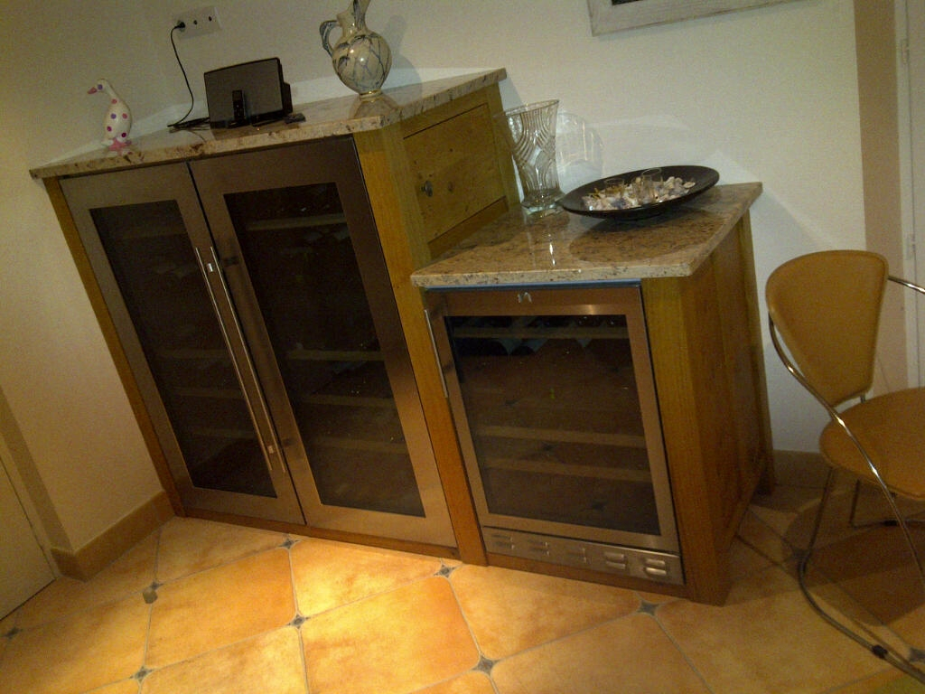
Glenn Designs is a Liebherr distributor; (concealed isolators & rear extract ventilation added to this installation,).
Domestic and Commercial Installations The granite tops on these oak cabinets perfectly set off this dual purpose unit; whether for domestic display or a work-station in a busy restaurant. This unit offers 4 temperature zones for steady storing of reds, whites and rose’s from 13- 15C and a slave cabinet for chilling to 6C.

Why not give us a call? 07886 489055. E-mail:fieldsfurniture@hotmail.com

Other products
Framed Wine Mirrors – another beautiful showpiece is our tinted or clear wall mirror framed in a wood of your choice, (oak, ash, maple, walnut) and has mountings bored through the glass which supports each bottle, stunningly it makes it look like the bottles are suspended in mid air.
With LED back lighting these made-to-measure units offer a unique light-for-living feature.
From £395 made to measure quotation on application

Table top wine stands - made in oak, ash, walnut, maple, burrs and the like - these simple stands from our gift range retail at £15.00.

Contact details 07886 489055. E-mail:fieldsfurniture@hotmail.com

Further aids to appreciating wineWeb information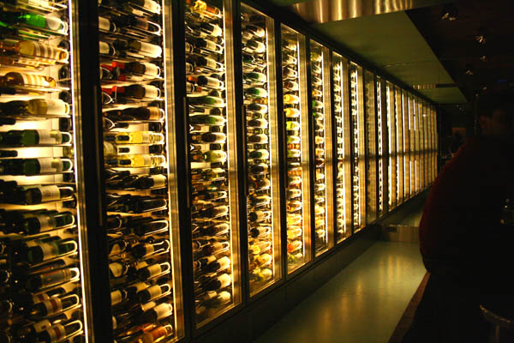
an installation in Amsterdam, by others.

Wine associations and suppliers – with their own wine tasters and selectors Wine Associations are superb for information, save a lot of time and supply wines from £4.75 to £250+.

